Images and Texts Project Proposal

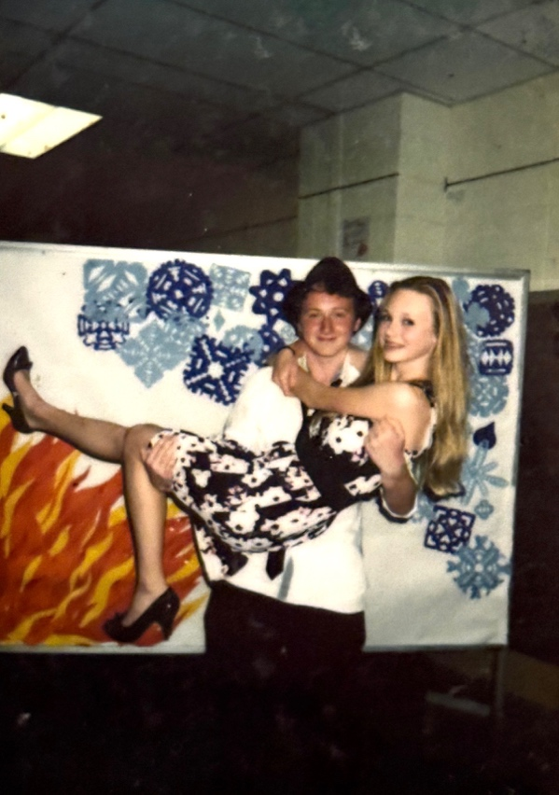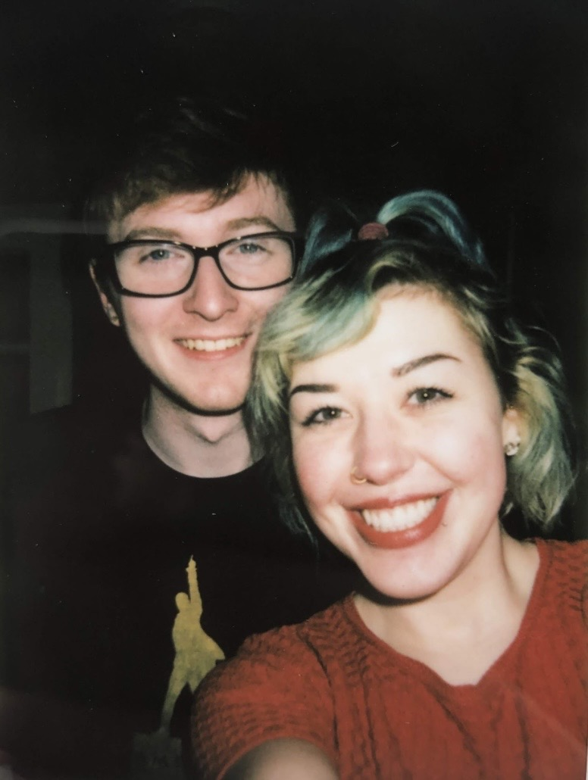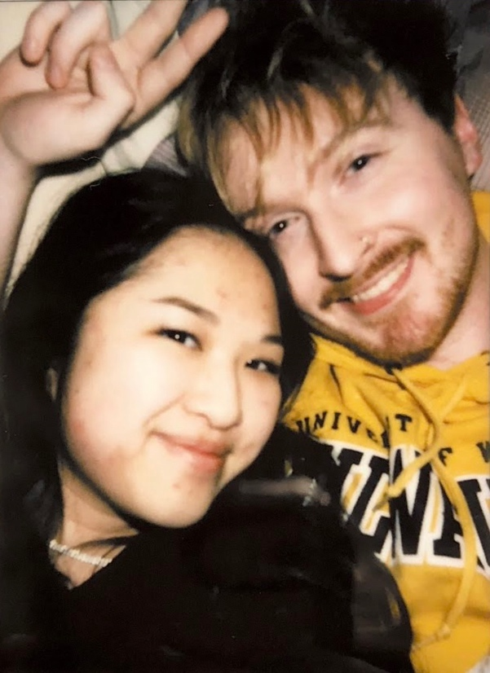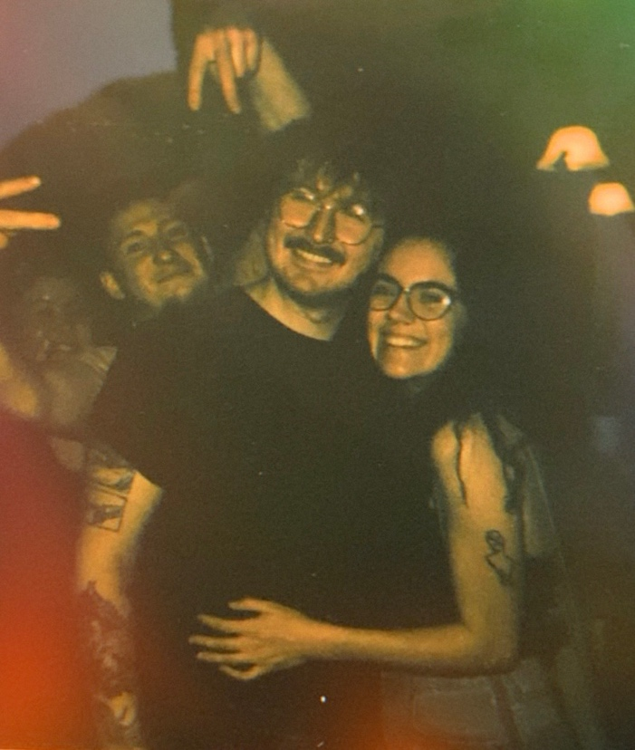

“I should have protected you more.”

Although I know the project proposal only calls for a single image, I feel that these four photos together are more impactful, and more indicative of my plan and feelings than descriptions of them would be. Much of my adolescent and adult life has been relationship-centric—I admittedly love being in love—and many of my experiences with love have shaped me both for better and for worse. I am someone who believes in keepsakes and photographs and memories being forever valuable, so I actively choose to hold onto the relics of my relationships past. That said, I have so many thoughts and feelings both resolved and unresolved that I believe I can uniquely express through a project like this.
My bonds with these people have been long since severed, but they exist in the background of my memory and life in ways that persist to this day. Nostalgia has always been a powerful feeling for me, and I choose to embrace that rather than reject it. Despite whatever love I still carry for them, many of my past partners have taken pieces of me with them as time passes. Today, I feel hollower than I once did, but I hope to recover those missing pieces in some way.

